**PROJECT REPORT**

|  |  |
| --- | --- |
| **Team ID** | PNT2022TMID19409 |
| **Project Title** | Smart Waste Management System For Metropolitan Cities |
| **Team Leader** | Sona T |
| **Team member 1** | Rithanya K |
| **Team member 2** | Srimathi V |
| **Team member 3** | Venkatesh Manikanda Prabhu |

**Introduction**

* 1. **Project Review**

The smart bin system undergoes a thorough system check and battery level monitoring in order to function efficiently. Once the waste bin is emptied, an information update is sent to the municipality and server is updated. The area in which garbage is found to overflow is allocated to respective garbage collectors.

* 1. **Purpose**

We combine technology and waste management to effectively create a safe and sanitary environment. Smart waste management is the use of technology and data to make the waste industry more efficient. Smart waste management, which is based on IoT (Internet of Things) technology, aims to optimise resource allocation, reduce operating costs, and increase the sustainability of waste services. This allows trash collectors to plan more efficient routes, but it also reduces the likelihood of any bin remaining full for more than a week. A good level of coordination exists between the garbage collectors and the information supplied via technology. This makes them well aware of the existing garbage level and instigate them whenever the bins reach the threshold level. They are sent with alert messages so that they can collect the garbage on time.

**2.Literature Survey**

**2.1 Existing Problem**

Waste management has become an alarming challenge in local towns and cities across the world. Open and unsanitary areas contribute to contamination of drinking water and can cause infection and transmit diseases. Toxic components such as Persistent Organic Pollutants pose particularly significant risks to human health and the environment.

**2.2 References**

**Paper 1**

**Title :** Smart Waste Management System

**Author Name :** Sanjiban Chakravarthy, Aniket Mehta, Shaheen Sheikh,

Dr. CR Manjunath

**Publication Year :** May 2021

Waste management is one of the most serious challenges facing cities today. The system now in use in cities continues to use an old and outmoded paradigm that no longer serves the needs of municipalities. We still find over spilled waste containers emitting irritating odours, causing serious health issues and air pollution. The Smart Waste Management System will simplify the solid and hydric waste inspecting process, as well as the total collection process of this presentation, using Web applications and mobile phones. GPS is used in the proposed system. The proposed device and implementation will track waste storage and monitor the waste driver of the vehicle. This method assists in making the customer aware of the accountability behind the job, such as the system for solidification.

**Paper 2**

# Title : Smart Waste Management under Smart City Mission -Its Implementation and Ground Realities

**Author Name:** Priyanka Mokale

**Publication Year :**

What are the objectives of smart waste management? Are people aware of it? Also try to understand the implementation of waste management from small town to the metropolitan city. At the end in the discussion try to show the difference between small-town waste management and how to manage it.

**Paper 3**

**Tilte :** IOT Based Waste Management for Smart City

**Author Name:** Parkash Tambare, Prabhu Venkatachalam

**Publication Year:** 2016

### We frequently see trash cans or dust cans in public spaces in cities overflowing due to an increase in the amount of waste produced each day in the current situation. We intend to build "IoT Based Waste Management for Smart Cities" to prevent this from happening because it makes people's living conditions unsanitary and creates unpleasant odours in the surrounding area. The proposed system includes numerous trash cans scattered throughout the city or on campus. Each trash can has a low-cost embedded device that tracks the level of the trash cans as well as an individual ID.

**Paper 4**

**Title :** Waste Management Initiatives in India for Human

**Author Name :** Waste Management Initiatives for Humans

**Publication year:** 2015

The purpose of this paper is to investigate the current methods used in India for the welfare of its people in various waste management efforts. The other goal is to provide advice on how to improve trash disposal procedures in Indian municipalities. This essay is based on secondary research. The system is improved by reviewing previous waste management reports and suggestions for improvement made by planners, NGOs, consultants, government accountability organisations, and key business leaders. It provides a comprehensive understanding of India's various waste management programmes and identifies areas where waste management could be improved for societal benefit. The essay attempts to comprehend the critical role that our country's official waste management sector plays.

**Ideation and Proposed Solution :**

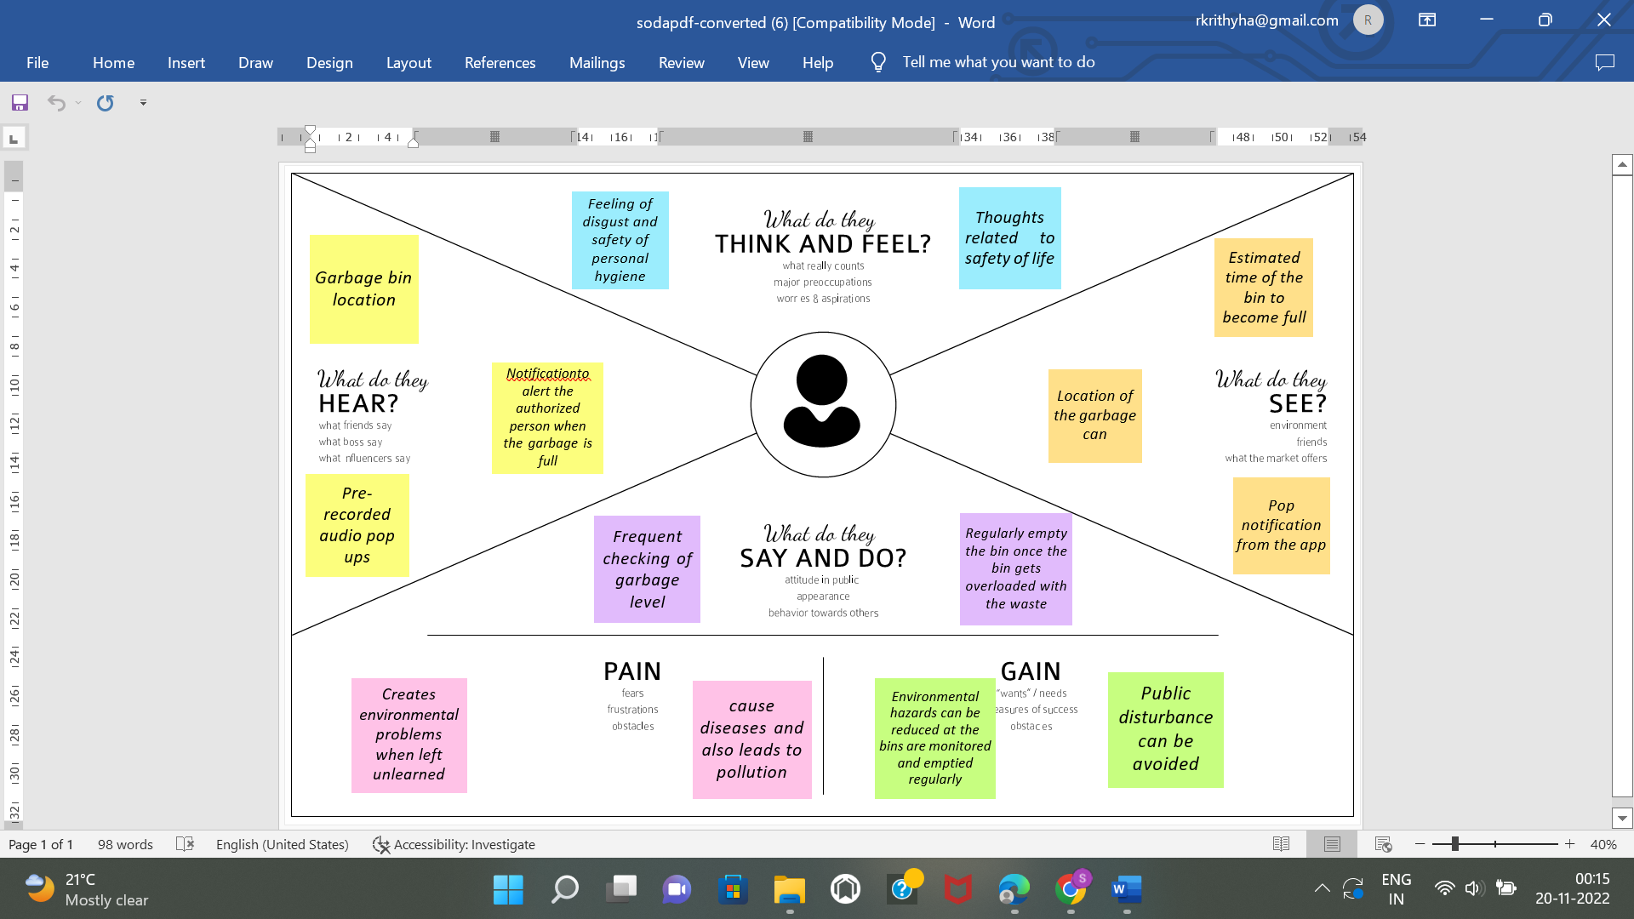

**Proposed Solution fit**

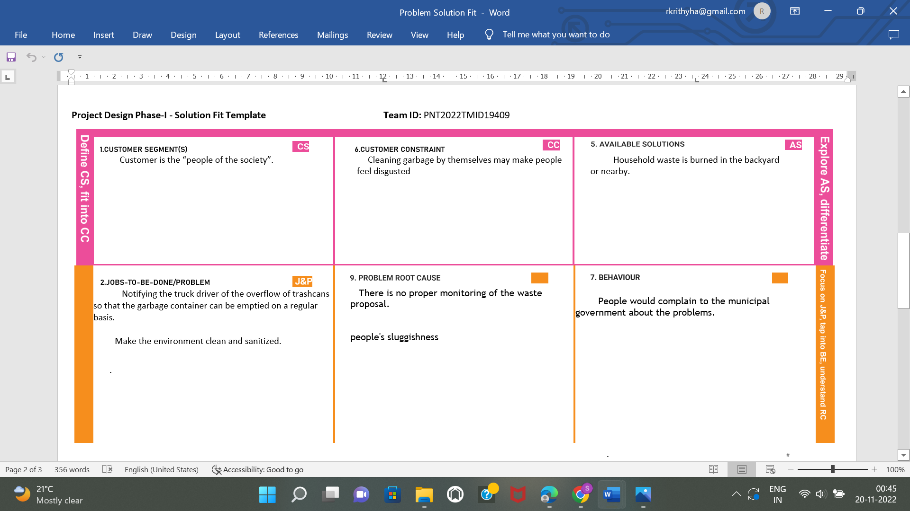

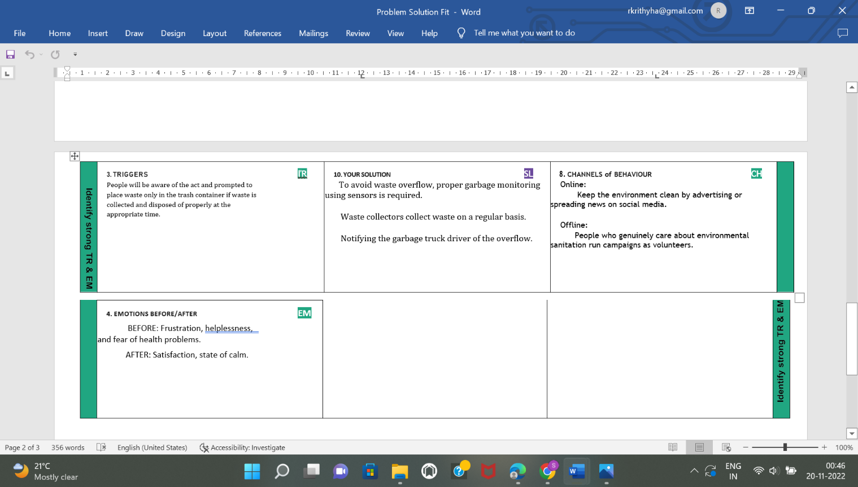

**Proposed Solution**

|  |  |  |
| --- | --- | --- |
| S.NO | PARAMETER | DESCRIPTION |
| 1. | Problem statement | The main issue with waste management is that waste is not collected on a regular basis because waste collectors are unaware of the overflow of trash containers. |
| 2. | Idea / solution description | The sensors detect the amount / level of waste in the trash container as people deposit waste in the trash container and notify waste collectors via the web application. |
| 3. | Novelty / Uniqueness | To dispose of their trash, homes and businesses across the country rely on routine waste collection services. Weekly services have been available for decades, but they aren't always the most cost-effective option.  Waste level sensors can be installed in bins. These devices collect and store fill level data, allowing collection services to forecast how frequently bins need to be emptied. This also prevents overflowing public containers from contaminating the surrounding area. |
| 4. | Social Impact / Customer Satisfaction | Aside from their economic and environmental benefits, the social benefits of "smart bins" are intriguing to citizens. They aid in: |
|  |  | 1. raise public awareness of the importance of environmental stewardship. 2. enhance street sanitation 3. collect and analyse waste volume data by area for better planning |
| 5. | Business Model | Waste Management generates revenue by providing residential, commercial, industrial, and municipal clients with a variety of disposal services and recycling solutions. |

**Solution Requirement:**

**Functional Requirements:**

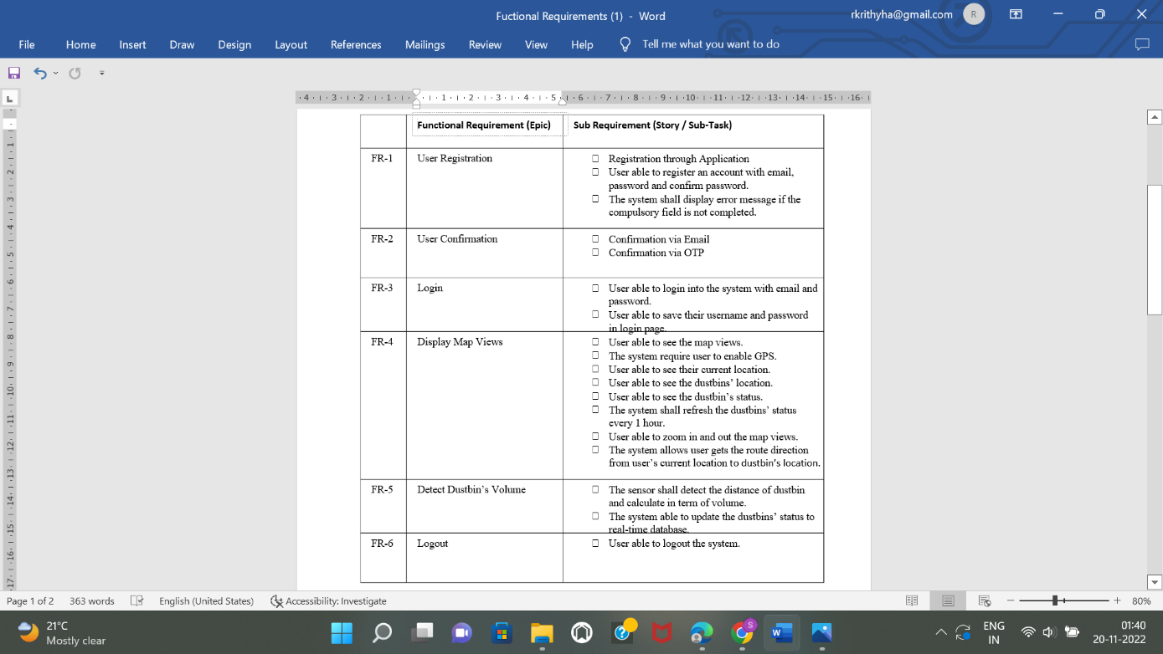

**Non Functional Requirements**

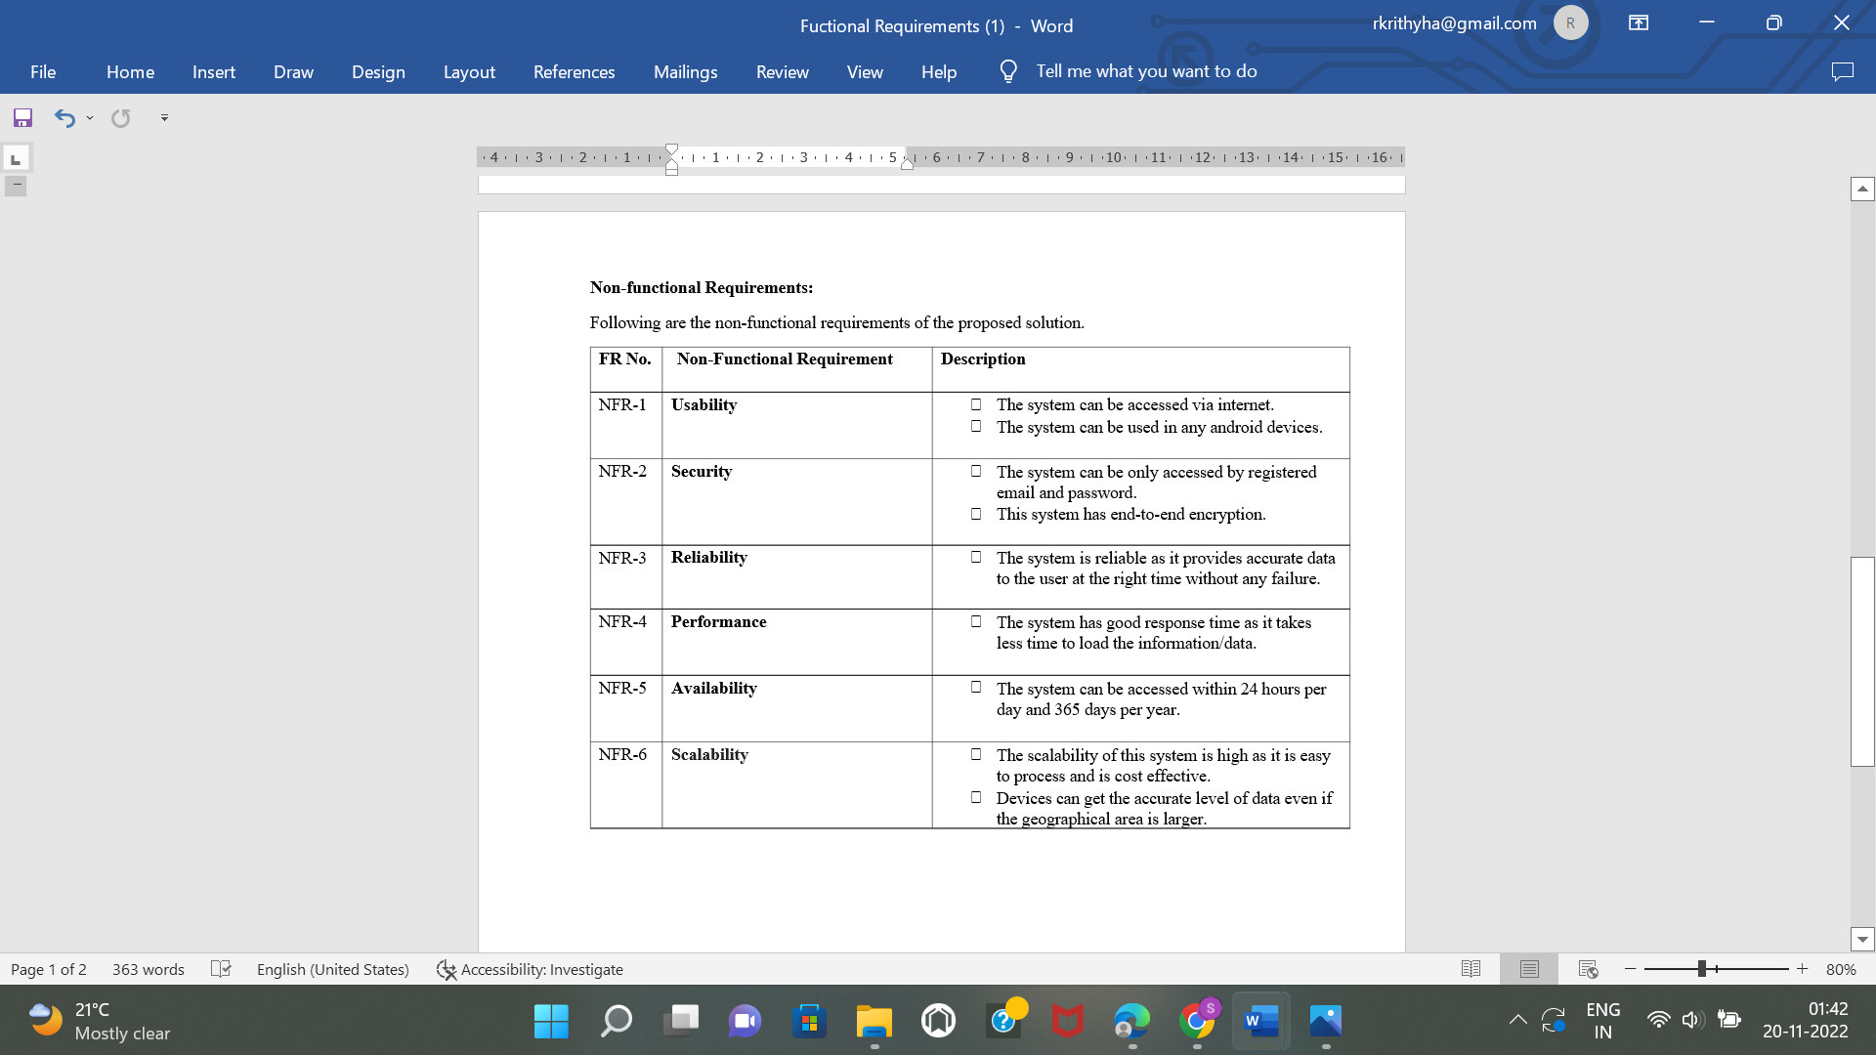

**3.Data Flow Diagram**

**3.1 Data Flow Diagram**

The classic visual representation of how information moves through a system is a Data Flow Diagram (DFD). A tidy and understandable DFD can graphically represent the appropriate quantity of the system demand. It demonstrates how information enters and exits the system, what modifies the data, and where information is kept.

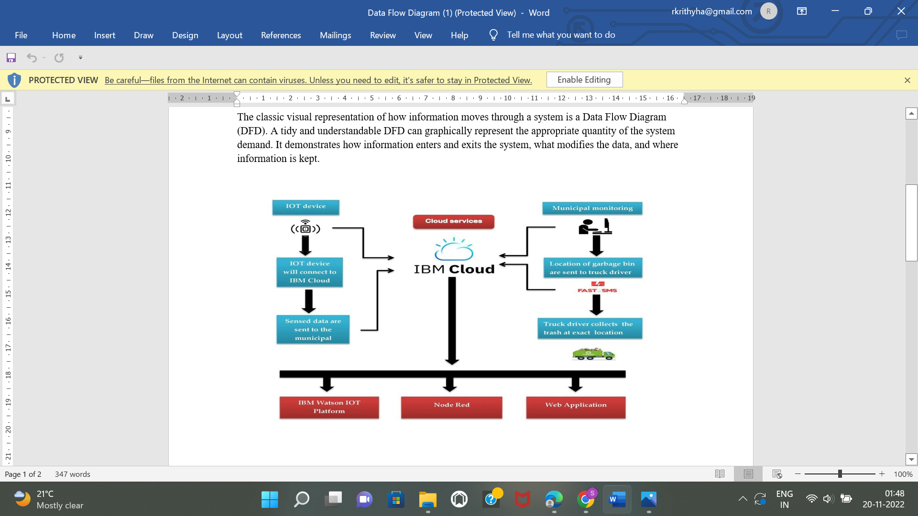

**3.2 Solution And Technical Architecture**

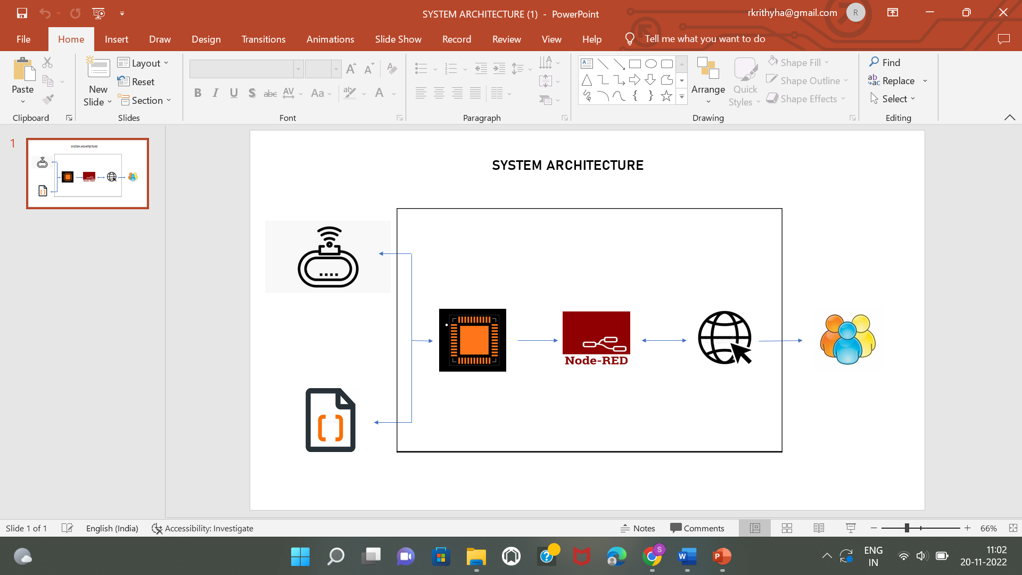

**Sprint Delivery Plan**

**Product Backlog, Sprint Schedule, and Estimation**

|  |  |  |  |  |  |  |
| --- | --- | --- | --- | --- | --- | --- |
| **Sprint** | **Functional**  **Requirements** | **Use Story Number** | **User story/Task** | **Story**  **points** | **Priority** | **Team**  **members** |
| Sprint-1 | Login | USN-1 | As an administrator, I am responsible for assigning user ids and passwords to all municipal employees. | 10 | High | Sona T |
| Sprint-1 | Login | USN-1 | As Co-Admin, I'll monitor the waste level through a real-time web portal. I will notify the trash truck of the location and bin ID once the bin has been filled. | 10 | High | Sona T |
| Sprint-2 | Dashboard | USN-2 | As a Truck Driver, I'll follow Co-instructions Admin's to get to the filling bin quickly and save time. | 20 | LOW | Srimathi V |
| Sprint-3 | Dashboard | USN-3 | As a Local Garbage Collector, I'II collect all garbage waste, load it onto a garbage truck, and transport it to landfills. | 20 | Medium | Rithanya K |
| Sprint-4 | Dashboard | USN-4 | As a Municipality officer, I'll ensure that everything goes as planned and without hiccups. | 20 | High | Venkatesh Manikanda Prabhu |

**Project Tracker, Velocity & Burndown Chart:**

|  |  |  |  |  |  |  |
| --- | --- | --- | --- | --- | --- | --- |
| **Sprint** | **Total Story Points** | **Duration** | **Sprint start time** | **Sprint end time** | **Story Points**  **Completed (as on**  **Planned End Date)** | **Sprint Release Date**  **(Actual)** |
| Sprint-1 | 20 | 5 Days | 24 Oct 2022 | 29 Oct 2022 | 20 | 16 Nov 2022 |
| Sprint-2 | 20 | 5 Days | 1 Nov 2022 | 5 Nov 2022 | 20 | 16 Nov 2022 |
| Sprint-3 | 20 | 5 Days | 6 Nov 2022 | 10 Nov 2022 | 20 | 16 Nov 2022 |
| Sprint-4 | 20 | 5 Days | 11 Nov 2022 | 15 Nov 2022 | 20 | 1. Nov 2022 |

**Advantages:**

• Lowering Collection Costs

• Analysis of waste generation

• Reduction of CO2 emissions

• No failed pickups

• Lower Overflows

**Disadvantages :**

• The system necessitates a greater number of waste bins for separate waste collection in proportion to the city's population**.**

• Because smart dustbins are more expensive than other methods, this results in a high initial cost. The memory size of sensor nodes used in dustbins is limited.

**Conclusion:**

By using sensors to monitor bin filling, it is possible to create a Smart Waste Management system that is more effective than the one currently in use. Our definition of a "smart waste management system" focuses on waste management monitoring, intelligent waste system technology, eliminating human intervention, minimising human time and effort, and creating a healthy and trash-free environment. The proposed approach can be implemented in smart cities where residents have demanding schedules that leave little time for garbage collection. If desired, the bins could be placed in a city where a large container could hold enough solid trash for a single unit. The cost could be prohibitively expensive.

# Future Scope:

There are several future works and improvements for the proposed system, including the following:

# 1. Modify the system of user authentication and atomic bin locking to help protect the bin from damage or theft.

2. The concept of green points would encourage residents or end users to participate, making the idea successful and assisting in the achievement of collaborative waste management efforts, thus fulfilling the idea of Swachh Bharath.

3. Having a case study or data analytics on the types and times waste is collected on different days or seasons, making bin filling predictable and removing reliance on electronic components, as well as fixing the coordinates.

4. Improving the graphical interfaces of the Server and Android.